Workshop1

# **Admin - Login-JobSeekers list**

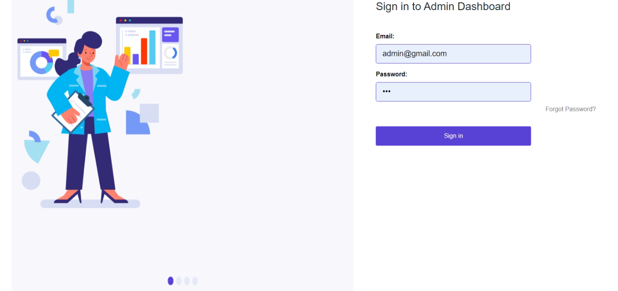

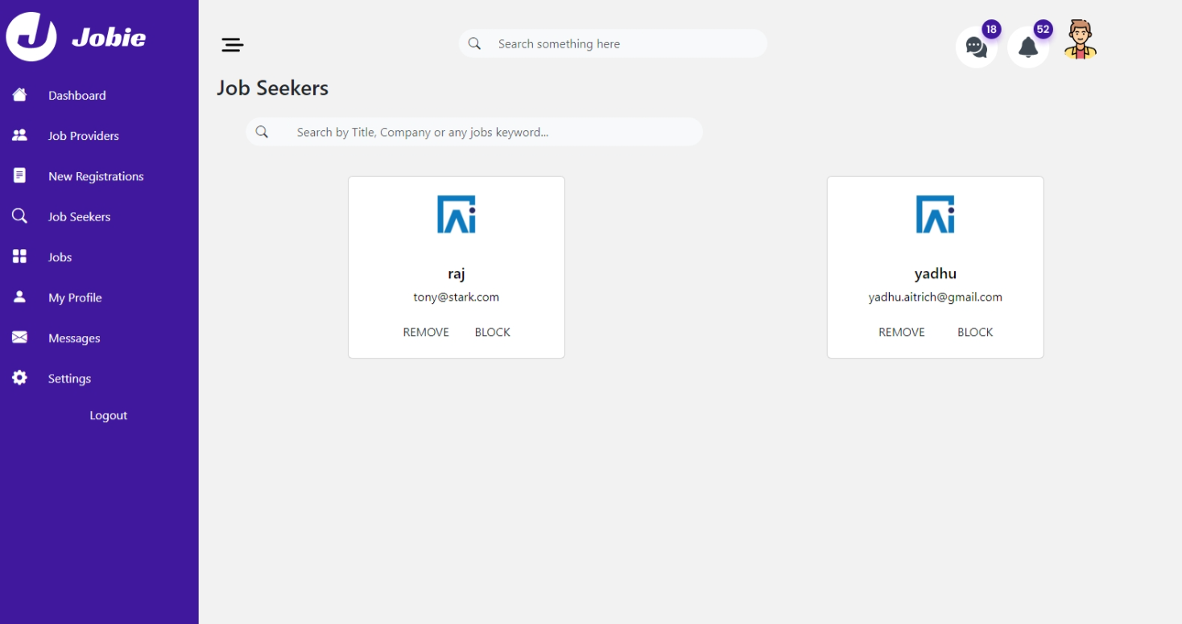

## 

### 

### **Overview:**

Blazor is a framework for building interactive web applications using C# and .NET. In this workshop, we'll explore the fundamentals of Blazor by creating an admin job list page for a job portal application.

### **Workshop Goals:**

* Understand the basics of Blazor and its components
* Create a job list page using Blazor components
* Implement functionality for the admin Login And job list page Using EF core

### **Prerequisites:**

* Basic knowledge of C# and .NET Core
* Familiarity with HTML, CSS, Bootstrap and JavaScript

### **Workshop Agenda:**

#### Part 1: Introduction to EFcore

* What is EFcore?
* How to implement EF core in blazor application
* How do CRUD Operations using EF in Blazor Applications

#### Part 2: Setting Up the Project

* Clone the Application and open in Visual studio
* Go through the Project structure overview

#### Part 3: Go through Ef operations in HireMeNowDbContext ,And Repositories

* Admin login
* Admin jobseeker list

#### Part 4: implement the functionalities mentioned below

* Implement Search in job seeker list page
* Implement Remove in job seeker list page
* Implement Block in job seeker list page(Change the status to BLOCKED)

#### 

### **Resources:**

* Visual Studio or Visual Studio Code
* .NET Core SDK